Thanksgiving Homework Project!
Interview a Grandparent or Elder

Students will join thousands of students from across the nation to record their interview and upload their recordings to the Library of Congress for future generations to hear!

Step one: Download the App or go to the website (info below)
Step two: Find a quiet place and start the interview
Step three: Upload to share/Click “Find people to follow” find Mrs Gunter’s Fifth Grade Class – follow us

**Students have their questions – they may want to practice before the actual recording

See information below:
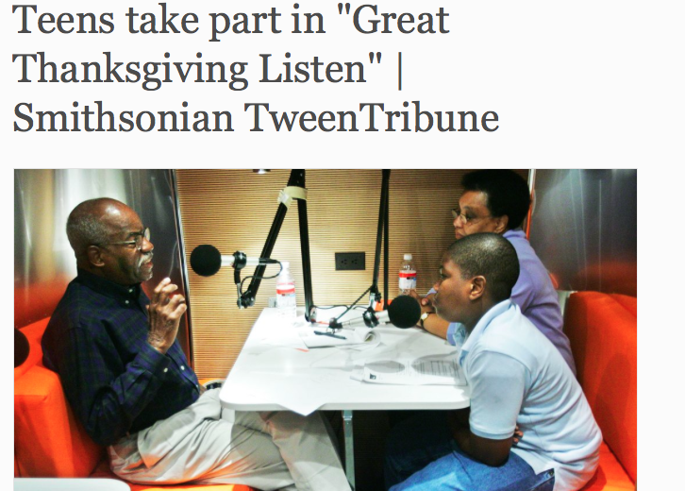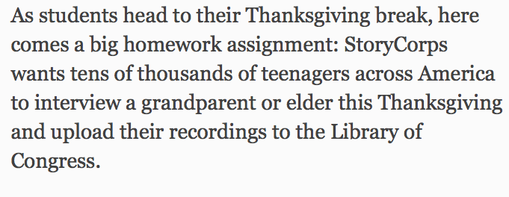

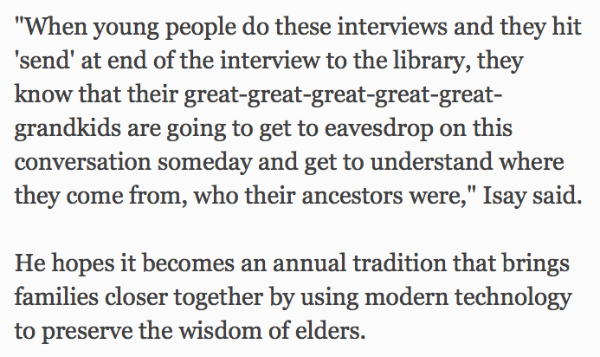

Link to the article:

http://www.tweentribune.com/article/teen/teens-take-part-great-thanksgiving-listen/

Link to the StoryCorps website for more info:
https://storycorps.me/

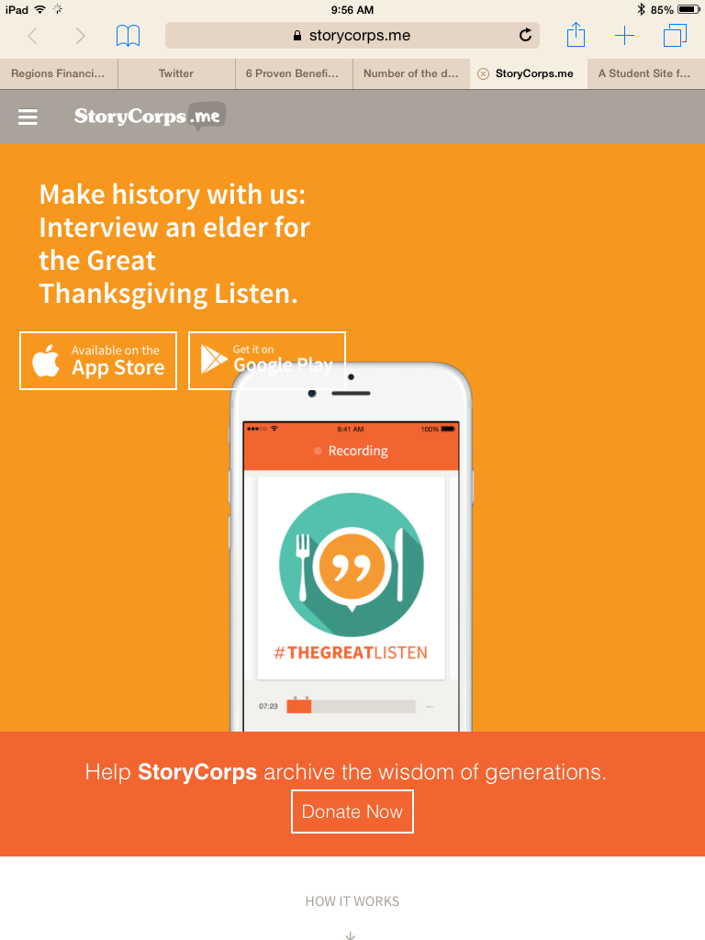
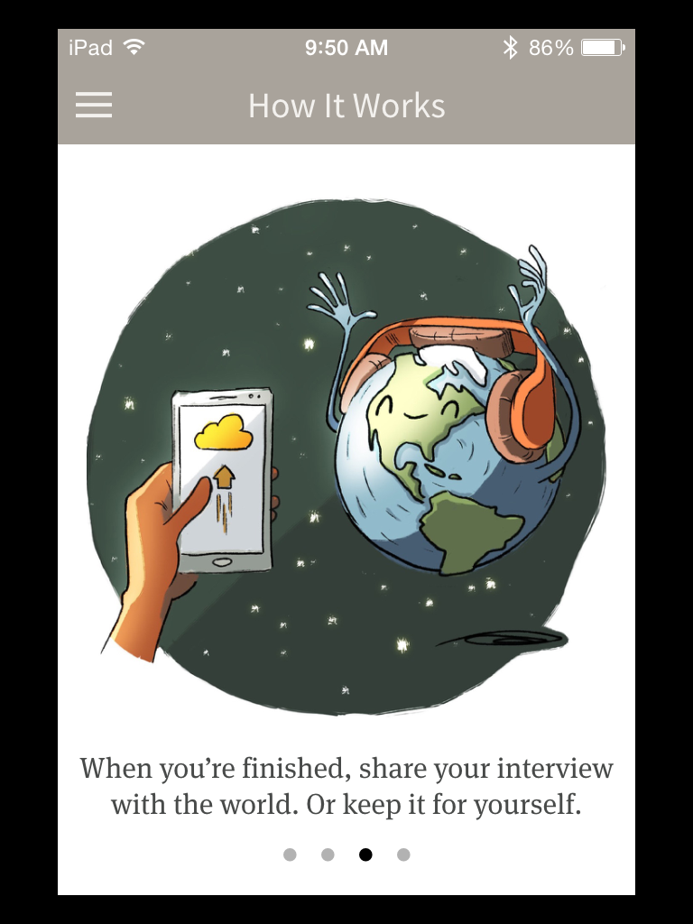
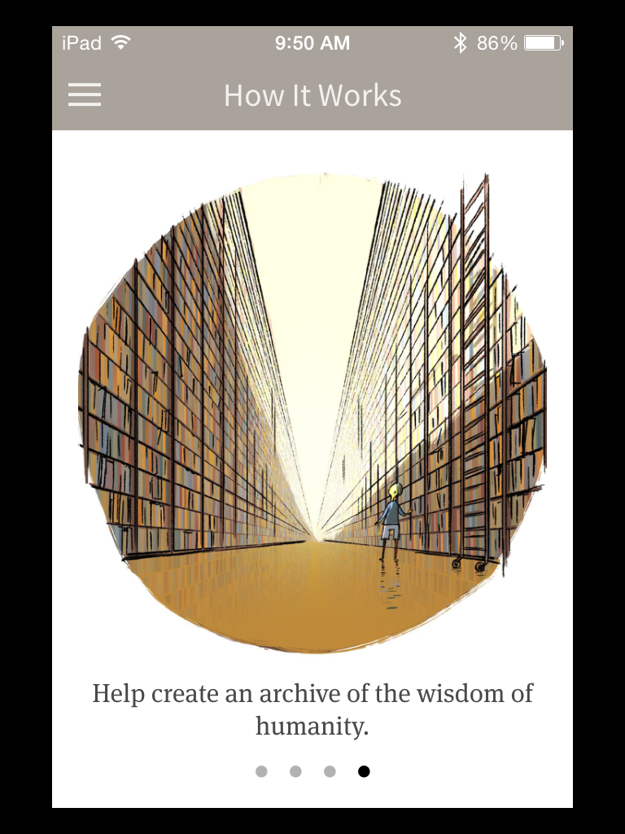

Storycorp.me when you search on your IPhone or Android

I hope this will be a fun activity and a chance to learn something new about our Grandparent’s Generation

I will put this page on my website under Social Studies so you can just click on the link. Email me if you have questions tmartinie@bcbe.org

Have a Happy Thanksgiving!
Mrs. Gunter

